Appendix 6

Test results for running 50,000 time steps with a public goods cost of 0.0001

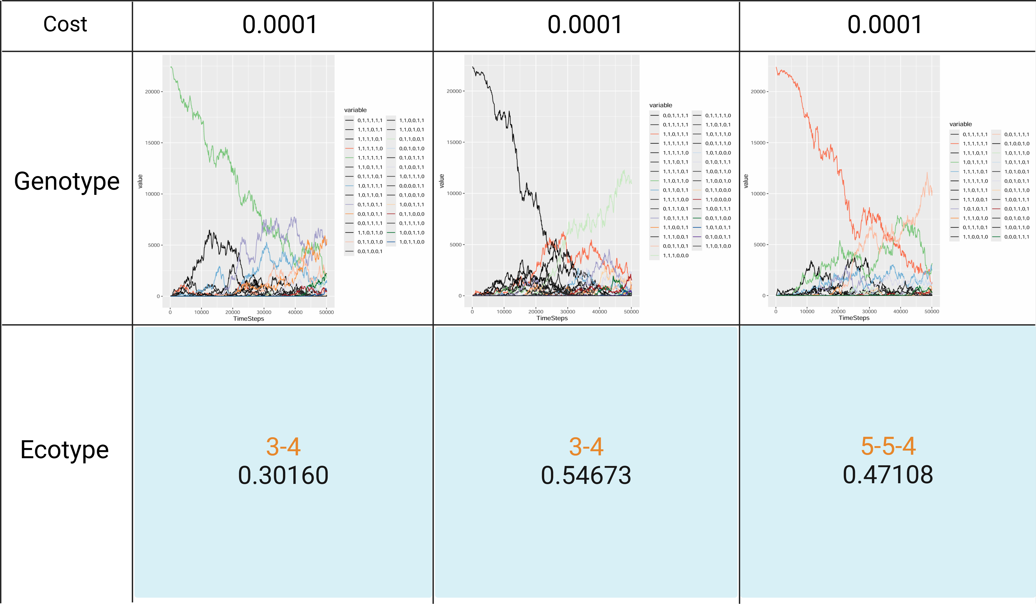
The genotype changes when the public goods cost is 0.0001, and the ecotype composition at the 50,000th time step. The parameter combination is "cost = 0.0001", "public goods production interval = 1", "public goods diffusion interval = 1", and "public goods decay rates = 0". The content in the second line of the ecotype section represents the proportion of public goods produced by that ecotype composition within the community. The removal threshold for the number of genotypes were genotypes with a proportion less than 1. In these three communities, the ecotype composition and evolutionary trajectory with a public goods cost of 0.0001 at the 50,000th time step are remarkably similar to those of the community with identical parameters but a public goods cost of 0.01 at the 5,000th time step. In both cases, the 3-producer, 4-producer, and 5-producer dominate within the community.

